|  |  |  |  |  |  |  |  |  |
| --- | --- | --- | --- | --- | --- | --- | --- | --- |
| **S** | **U** |  |  | **Z** |  | **G** | **A** | **R** |
|  | **D** | **O** |  | **E** |  |  |  |  |
| **K** | **U** |  |  | **N** |  | **D** | **E** | **N** |

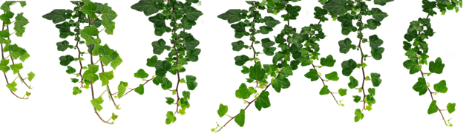

Usability Testing Report

Date of Report: April XX, XXXX

Date of Test: April XX, XXXX

Location of Test: UMass Lowell, MA

Prepared for: Professor Jesse Heines

Email: [heines@cs.uml.edu](mailto:heines@cs.uml.edu)

Prepared by: Dylan Wetherald, Martin Rudzki, and Michael Bejaniance

Email: [Dylan……………………..](mailto:Marting_Rudzki@student.uml.edu)

Email: [Marting_Rudzki@student.uml.edu](mailto:Marting_Rudzki@student.uml.edu)

Email: [Michael…………………………](mailto:Marting_Rudzki@student.uml.edu)

Table of contents go here

What we are graded on:

|  |  |
| --- | --- |
| *Criteria* | *Possible Points* |
| **Usability Documents and Notes**   * instructions to test subject * task list to be given to subject * evaluator form * questions to be asked of subject | 8 |
| **Report**   * clearly describes what test subjects did and what happened during the test * identifies user interface features with which test subjects had success and features with which they had problems * suggests improvements that might be made to address those areas of the program with which test subjects had problems | 10 |
| **Analysis**   * discussion of the changes you plan to make in the final version of your software based on these results ***and why*** * discussion of the changes your tests indicate should be made but that you simply don’t have the time to make * your conclusions about the quality of your user interface ***and the usability testing experience in general*** | 8 |
| **Presentation**   * professional look * logical organization and structure * correct spelling and grammar * adherence to paper layout and writing guidelines | 4 |

# Executive Summary

The goal of this study was to setup a usability test for our website Sudoku Zen Garden with the help of group of testers it would allow us gain critical feedback on how user-friendly the application is. Continue………………

# Methodology

## Who we tested

## Instructions and Task List for Testers

## Questions for Evaluators

## What did the testers do

## What data we collected

We collected data on how easy our website was to use, what testers enjoyed about it, and most important, the testers constructive feedback to improve our site. We ended our conversation with asking them if they would want one feature added and what would that be?

(ADD CHART HERE)

# Major Findings and Recommendations

* List major issues -
* Identify solutions -

# Detailed Findings and Recommendations

(ADD CHART HERE)

## Introductory Questions & Tasks

|  |  |
| --- | --- |
| **Sample Questions** | **Sample Responses** |
| Have you heard of [site]? | None of the participants had been to or heard of the site. |
| Just from looking at this site, what kinds of information do you think you could get from this site? Please be specific. | All participants correctly defined the purpose of the site. Participants used phrases from major headers and labels to describe the information on the site. |
| Who do you think this site is designed for? Why? | Participants correctly identified general public. One person suggested doctors and nurses. |
| Who manages this site? | One participant identified the sponsor from the masthead. |